Friese for Sisking Hours Wed. and Fri. November

Susan Schwalb 1997 67 L113D Strata #143 Metalpoint

Nannette Carter 1995.001 P103
Containment #4 Transfer Drawing on Mylar

Manual of the Mustard Seed Garden 49.453.3 Drawer B218
One volume.

Larry Day 2005.109.1B
No. 2: The Establishment of Ritual. Graphite and Watercolor

Thelma Wood 30.014. 1929
Puma. Silverpoint

Joseph Turner 69.154.59
Pass of St. Gotthard, Switzerland watercolor

Gertrude Goldschimdt 70.040
Lithograph

Nancy Graves 2010.75
Mushrooms and Chinese Calligraphy ink

Suzanne McClelland 2009.90.2
Lullaby #31, Blue Hoop with God. Monotype with Collage

Richard Joseph Neutra 39.142.5
Perspective John Nicholas Brown House Graphite

Edward Lear 71.153.56
The tree, stands in the sun, and shadows all beneath,” Calcutta, India,

Some Images of Reserved Works;
Richard Joseph Neutra
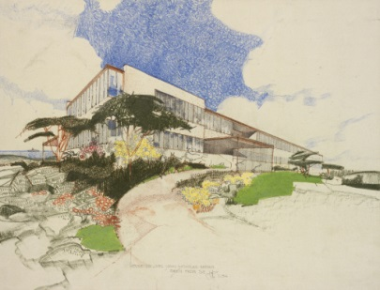
Perspective view of the John Nicholas Brown House, 1936-38
Diazo print with colored pencil and graphite
(10 3/16 x 14 1/8 inches) (sheet)39.142.5
Nancy Graves American, 1940-1995  Mushrooms and Chinese Calligraphy, 1972  India ink, graphite, and gouache on Arches Satiné paper  (30 x 22 1/2 inches) (sheet) 2010.75 |  | 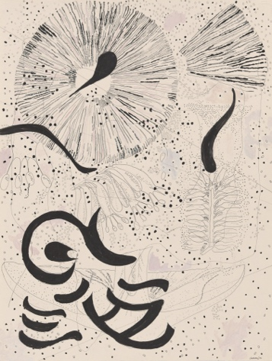
Gertrud Goldschmidt (Gego), printmaker  Venezuelan, born Germany, 1912 - 1994  Untitled, 1966  Lithograph on paper  (32 3/16 x 23 1/8 inches) (plate) 70.040 |  | 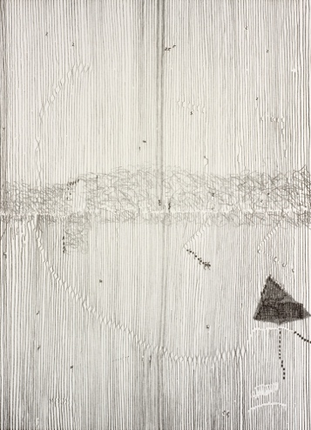
Thelma E. Wood
Puma Silverpoint
30.014. 1929
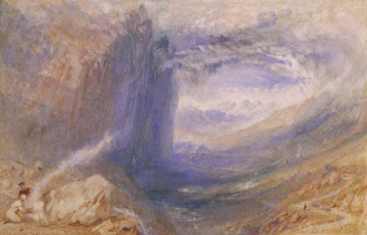

Joseph Mallord William Turner English, 1775-1851
Pass of St. Gotthard, Switzerland , ca. 1842-1843
Watercolor, ink, and graphite on wove paper
(8 7/8 x 11 1/4 inches)69.154.59

Larry Day No. 2: The Establishment of Ritual
2005.109.1B.
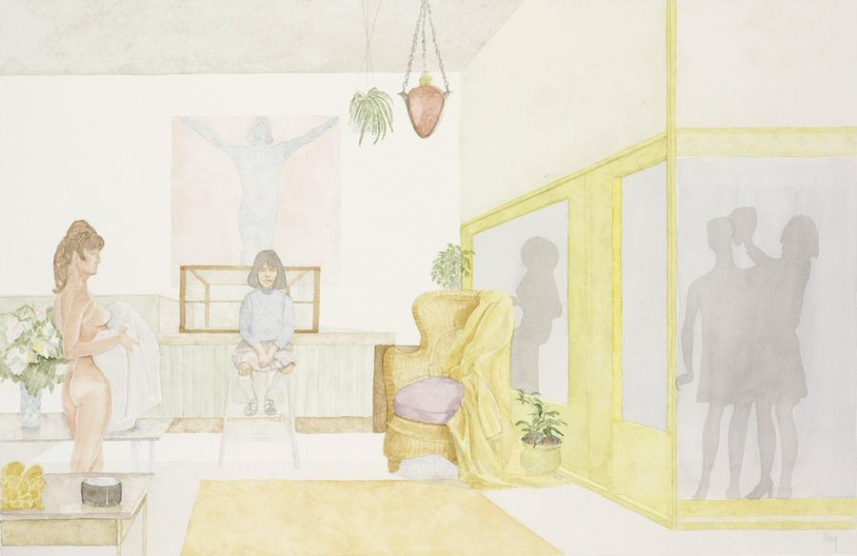

Suzanne McClelland
Lullaby #31, Blue Hoop with God. Monotype with Collage
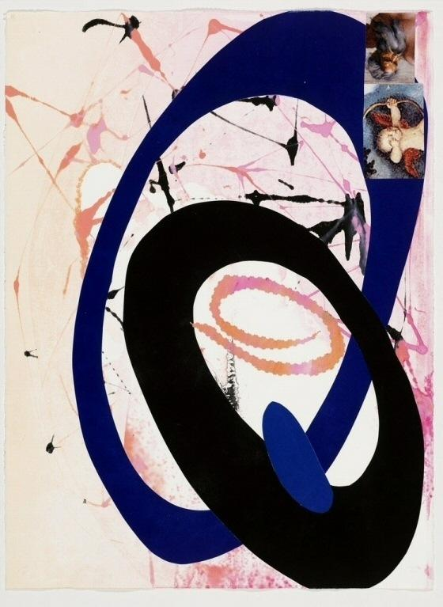

Nanette Carter Containment #4
Monotype on Mylar

