What is a Designer Statement? (Part 3): Ponik, Lupton, Eatock, Nelson, Yegir
BY
Vadim Gershman
FILED TO
Design
DATE
Dec 7, 2011
SHARE
twitter facebook email
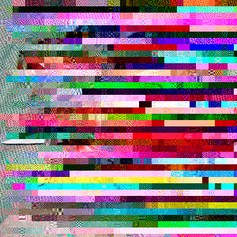
This is part 3 of an ongoing survey. See part 1 here, part 2 here.
As a design candidate in the MCAD MFA program I was asked to write an “artist statement” which, as a designer, I found inherently problematic. In response I contacted designers whose work inspired and influenced me in some way, asking:
Is there such a thing as a “designer statement,” and if so, how would you go about creating one?
I received responses from 30 designers and studios which I will present here in the coming days. Many of the designers in this survey are represented in the current show Graphic Design: Now in Production.
David Reinfurt (Dexter Sinister)
vadim,
i suppose i have a response which will at first seem glib — of course, a statement (of intent, purpose, subject, whatever) is something that designers are very often actually asked for. usually these things flow out in the either a. hackneyed language of marketing, or b. hasty recounting and slight re-wordings of someone else’s definition of design. a much stronger version is to make your work do the stating, so that a ‘statement’ as such is redundant. i do realize that this is often hard to practically make work, or make legible anyway. so we continue to write our own bios and frame our own practices. in which case, a designer statement is best read between the lines of a bio (perhaps), or (better) in the connecting threads that run one project to the next. i dont see much use in artist’s statements anyway, as it is much nicer to manifest an approach and model a way of working than to describe an agenda and illustrate it through works.
you might notice the distinction between ‘works’ and ‘working’ — this is crucial.
hope this ramble proves useful,
david
——-

James Goggin (Director of Design, Print, and Digital Media, MCA Chicago)
Hi Vadim,
A really late reply from me, I do apologize. But I was pleased to receive your email and I will happily answer your question.
I’m with you on the notion of a designer statement being a problematic one. Given my own practice which is constantly influenced and directed by the given circumstances of any project’s content and context, I would likely soon contradict any statement I might make as a designer. But perhaps that in itself could be a valid statement: the conscious avoidance of one ideology or dogma but rather the recognition of the parameters and constraints placed on designers, and the willingness to embrace and subvert them.
A bigger question is perhaps not “how would you go about creating a designer statement” but more “for which audience is a designer statement actually intended”? The application of design parameters onto the very question of a designer statement.
As a test of the above, I am going to revisit an unfinished interview that Emmet undertook with me a few years ago (unfinished by me, unintentionally, just due to being to busy and disorganized — he asked some great questions) to see if, in those “designer statements”, I still agree with them, or if I have since contradicted myself. I hope I have.
Thanks for your great question, I look forward to seeing your results. Come and say hello when I’m at the Walker in March.
Best regards,
James
——-

Keetra Dean Dixon
hi hi,
Hope this response fits the bill. So excited to see the discourse!
—
Q: Is there such a thing as a “designer statement,” and if so, how would you go about creating one?
A: There are a lot of design manifestos, initiatives, philosophies, missions and methods. Regardless of the titling, a statement outlining ones approach to work is an invaluable guide. The work we produce carries the mark of our perspective (be it grand or subtle) whether we intend it to or not. It is vital that we understand our own voice in order to contribute responsibly and extract greater meaning from our endeavors. For me, stating my goals can help move my work from intuitive to intentional. “Designer” is such a nebulous title; further defining the role for myself is key to directing my own path and its resulting impact.
I developed a half-hearted traditional artist statement when I began showing work in galleries, but I developed the most useful writing during my graduate studies at Cranbrook in response to the completely open, almost unstructured program. I needed guidance. I developed a structure to self-apply. I extracted my own voice, creating a set of guiding statements to keep me on a broad, but directed path. I still look to, and continually evolve two of sets of those guides: “What the work wants to do” (my initiatives) and “Reminders when making” (my methods). They cover the grand concerns of what am I doing & how I am doing it.
Thanks again for the inquiry!
BEST LUCK
kdd
——-
Look for more responses soon!
Get Walker Reader in your inbox. Sign up to receive first word about our original videos, commissioned essays, curatorial perspectives, and artist interviews.

——-


Scott Ponik
I have to apologize for the radio silence, once again. Very sorry. In regards to your question:
I recently had a friend refer to an artist statement as their “jingle.” In case you don’t know, jingles are a short tune used in advertising, something catchy that will make you remember the brand it’s used for. They’re a form of sound branding, the ultimate situation of a “song stuck in your head.” A classic example:
“I am stuck on Band-Aid, ’cause Band-Aid’s stuck on me!” Written by prolific jingle producer, Barry Manilow. Link
An artist communicating their “jingle” is similar in that it should be memorable, in 1 or 2 sentences, that “ah-ha moment”, “so that’s what it’s all about”, “I’ll take one.” Although it’s hardly ever that simple. What about the artist who wants to confuse the reading of his/her work? Etc. Etc.
I think this might be what you’re referring to as “problematic.” With designers, being able to sum up an assignment in 1 to 2 sentences is graphic design 101. We typically have no problem talking about the reasons behind any given project, but when posed the simple question “What is your work about?” it’s practically crippling. Although paralyzing at first, it’s a question that lights a fire. The question already implies there’s an agency to the work. The answer could be called a statement, or a thesis, I’m not sure, but I think trying to answer it should be exercised.
Maybe the problem is in the question: As part of our studies, we were asked to write an “artist statement.” It seems like it’s leading you to a dead-end, or somewhere that may result in a jingle. ?
Sorry if I just made matters worse.
Sincerely,
Scott
——-
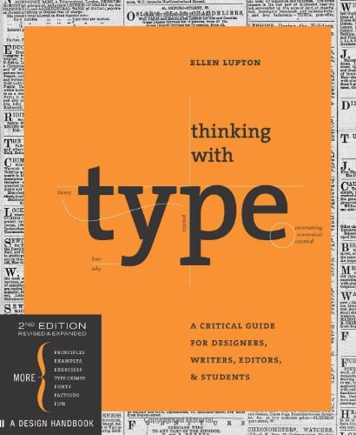

Ellen Lupton
Some designers call them manifestos. For an artist today, writing a manifesto would seem ridiculously out-of-date, but many designers have embraced the retro-vanguard directness of posting your beliefs in some kind of list. It’s an opportunity to say what you believe with humor and clarity, and it’s a format that people seem to understand. Bruce Mau, Bruce Sterlling, Emily Pilloton, and Ulla-Maaria Engeström have all written provocative and influential manifestos.
This is one of my personal favorites (concise, witty, and direct):
http://www.hobbyprincess.com/2005/03/draft_craft_man/comments/page/2/
It was published in MAKE magazine, also no stranger to manifestos.
el
——-
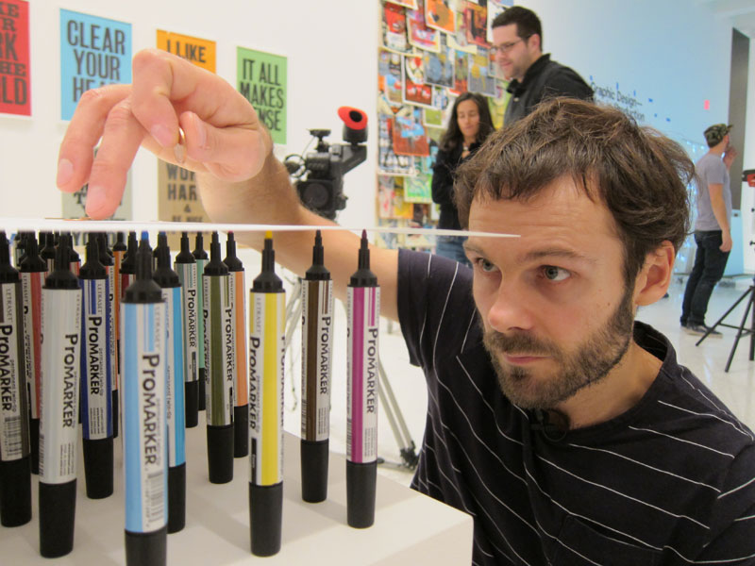

Daniel Eatock
Hello
Artist Statement for IASPIS:
Using my background knowledge from working as a graphic designer, I employ a rational, logical and pragmatic approach when making work. I have an ongoing interest to proposing and finding solutions to problems, often problems that cannot be formulated before they have been solved, the shaping of the question is part of the answer. I look for things to fix or improve, working like a tinkerer/inventor, I propose alternatives to existing models, preferring to find ways around doing things properly, bypassing the struggle. I use self referentiality as an objective guide to reduce the extraneous and subjective, and strive for a conceptual logic. The idea is paramount and the material form secondary. My website is a tool where I both create works, and index and exhibit projects chronologically. I propose systems, templates, invitations and opportunities for collaboration, creating social networks where contributors shape the outcome and participate in the building of works. I embrace contradictions, and dilemmas. I like gray areas, oxymorons and the feeling of falling backwards. My favorite colour is the purple found in a soap bubble. I prefer to swap and exchange things rather than use money. I seek alignments, paradoxes, chance circumstance, loops, impossibilities and wit encountered in everyday life. I often change my mind, go full circle, and arrive at the beginning.
Daniel Eatock
——-

Ryan G. Nelson
Hello again Vadim,
I think you’re question is an intriguing one. I’ll do my best to assemble my thoughts on the matter —
*********
Yes, I do believe that there is such a thing as a “designer statement” and I also believe that periodically crafting one is a relevant and important step for any serious designer. That said, I also imagine that there are many people (designers included) who would scoff at the idea of a designer statement.
A designer statement certainly is not a subject that makes its way into the fore of conversations surrounding design issues very often. But, my theory is that, if interjected into these conversations in some way, this subject would subsequently spark debate amongst designers from many different groups and schools of thought. For example, because a designer statement so readily brings to mind the artist statement, I think that a lot of people would find themselves in the middle of the ever-present art versus design debate (Can art be design? Can design be art? Where does the boundary begin and end? Is a designer an artist? Et al.).
I can also just imagine all of the different reactions designers would have when asked about designer statements—I’m guessing opinions on the matter would range from “crucial” to “unnecessary” to “strategic” to “cliche” to “pompous.”
Personally, I have taken the time and energy to craft my own designer statement because I’ve found that the process of doing so is beneficial to my own practice and to the way in which I present myself and my work. On average, I’ve written a new statement or edited and/or reconfigured a previous one every six months or so (each iteration typically being posted on my website). That may sound tedious and time-consuming, but I find it completely natural considering that I’m continually learning and evolving as a designer as well as gaining knowledge about certain subjects and viewpoints (design related and not) that tend to build upon or change my outlook on design and how I practice design.
I think many designers may be able to file their thoughts about design and how those thoughts have progressed through the years in their mind, but I’ve recently become more interested in actually recording those thoughts on paper as a way to start building a personal history that I can then use as a basis for introspective analysis of my work and principles.
To answer your question about how to go about crafting a designer statement …
Until recently, I had never used any sort of methodology to structure my statement. Though perhaps as a result of writing and re-crafting numerous statements, I’ve been able to develop a number of core questions that I ask myself in order to build up the framework of my statement. The questions, in no particular order, are as such:
— What defines the state of my practice? (i.e., What current ideas/influences/references are important to me as a designer? What am I reacting or responding to?)
— What factors define my methodology?
— What principles guide and shape my practice?
— Lastly (the newest addition to the set of questions I ask myself), there are a number of very simple and straightforward questions I ask that are borrowed from an excerpt written by the NYC design studio 2×4 for their recent “It Is What It Is” project/publication (http://www.iiwii.org/):
“Designers have their own private agendas, ambitions, anxieties, compulsions, and references that they attempt to implement. Those agendas may mesh with the content at hand … or may be grafted onto content and live on parasitically. Personal vision is the designer’s value-added; it’s an indexical presence assumed so resilient it can survive in any context, from the base to the effete.”
In speaking about “agendas” and “personal visions” this excerpt not only implicitly refers to (and perhaps argues for) the designer statement, but it has also posed some simple questions to me that I now use in the process of crafting my statement:
As a designer, what are my … agendas? ambitions? anxieties? compulsions? references?
Each of these questions are very simple and honest and, of course, are things that all designers think about consciously and subconsciously. Therefore, I’ve found that this last set of questions allows me to build upon my statement in a very frank way.
*********
Thanks again for posing the question to me, Vadim! Let me know if you have any questions or want any clarifications on my response.
Best of luck to you on your graduate work!
Talk to you soon,
Ryan
——-
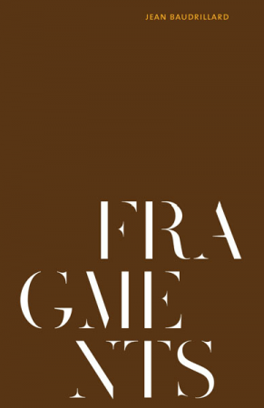

Edvin Yegir
Hope this note finds you well.
Rather quickly: The below may seem rather dismissive of your question, nevertheless;
Why not simply use PROJECT STATEMENT [as it is universal and all inclusive] and do away with ARTIST STATEMENT vs DESIGNER STATEMENT or whatever other craft ascribed prefix as they tend to be unnecessarily particular and exclusive.
Such statements usually describe the work at hand in any case and the title ascribed to the maker [imputing a particular discipline] is somewhat irrelevant. Additionally we no longer fit into clear delineated categories as the lines between disciplines are can be quite fluid.
BEST / E
——-
Look for Part 4 soon!
Get Walker Reader in your inbox. Sign up to receive first word about our original videos, commissioned essays, curatorial perspectives, and artist interviews.

