Developing and Writing a Diversity Statement
by Sara L. Beck, CFT Graduate Teaching Fellow | Print Version

Cite this guide: Beck, S. L., (2018). Developing and writing a diversity statement. Vanderbilt University Center for Teaching. Retrieved [todaysdate] from https://cft.vanderbilt.edu/developing-and-writing-a-diversity-statement


- What is a diversity statement, and what purpose does it serve?
- What topics might be included in a diversity statement?
- Getting Started
- Writing Prompts
- Adapting your Statement for a Job Application
- Additional Resources
- References

What is a diversity statement, and what purpose does it serve?
Increasingly, institutions of higher education are becoming more intentional and programmatic about their efforts to embrace principles of inclusion, equity, justice, and diversity throughout campus life. As they do so, they are more focused on finding faculty who have experiences and competencies that can contribute to these efforts. Consequently, universities and colleges frequently are requesting that job applicants address how they can contribute to a culture of inclusion and equity within the campus community in the form of a “diversity statement.”
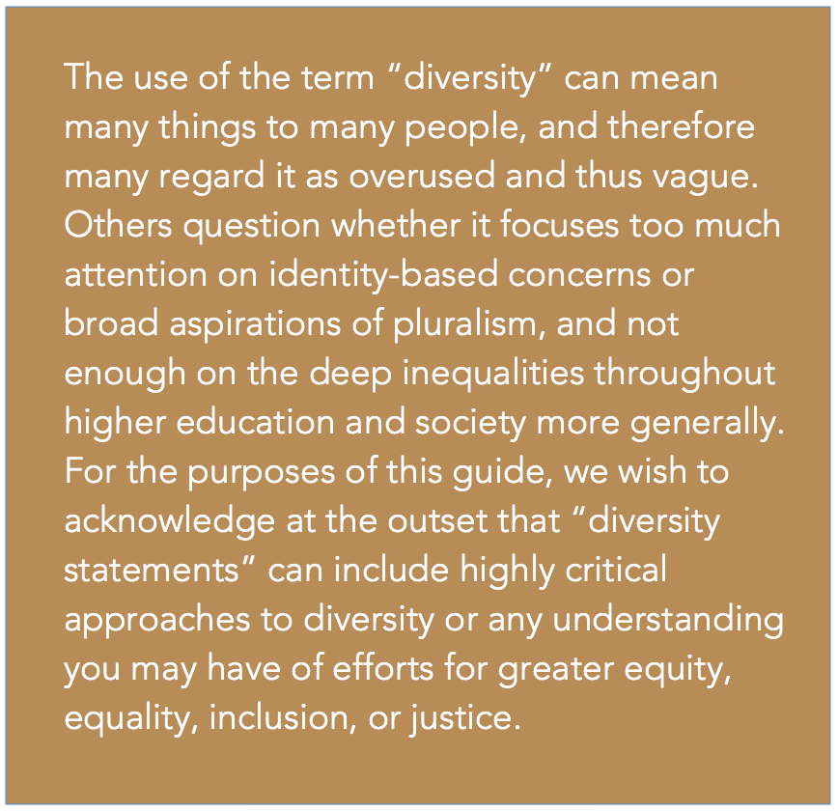
Sometimes, a job ad will request that applicants address diversity in the cover letter or the teaching statement, but a request for a separate diversity statement is becoming more common. From the perspective of the university, the purpose of this document is to demonstrate that the applicant has commitments and capacities to contribute to the institution’s projects of inclusion and equity via his or her work, including scholarship, teaching, service, mentoring, and advising. Melissa Thomas-Hunt, Vice Provost for Inclusive Excellence at Vanderbilt University, explains that asking faculty applicants to speak to inclusive excellence in their application materials or during the interview process shows the university’s commitment to inclusion and ensures that new faculty share that commitment (2018). The document is also an opportunity for applicants to highlight their understanding of the barriers faced by under-represented or marginalized groups, as well as their own experiences meeting the needs of a diverse population of students, staff, and peers. For example, The University of California at San Diego requests a separate “Contributions to Diversity” statement from all faculty applicants, and its published guidelines suggest describing “your past efforts, as well as future plans to advance diversity, equity, and inclusion.” (2.1.18, https://facultydiversity.ucsd.edu/_files/c2d-guidelines.pdf).
The wording that universities and colleges use in framing the request for a diversity statement varies widely. Below are a few examples from job ads posted in the 2017-2018 academic year.

St. Mary’s College of Maryland (public liberal arts college, faculty posting in Psychology):
Applicants should submit a statement explaining how their teaching at the College will contribute to a culture of inclusion and campus diversity.

Denison University (private liberal arts university in Ohio, faculty posting in Anthropology):
A description of how the applicant would contribute to the development of a diverse and inclusive learning community at Denison through her/his teaching, research, and/or service.

Angelo State (public university in Texas, faculty posting in Engineering):
The required Other Document should be no longer than 2 pages and should discuss how the candidate would help achieve Angelo State University’s goal to attract and graduate more women, Hispanic, and students from other underrepresented groups.

Georgia College and State University (public liberal arts college, faculty posting in Psychology)
Qualified candidates should submit a research statement, and a diversity statement (describing how you incorporate diversity into your teaching, research, and/or service). Teaching, research, and diversity statements should be limited to two single-spaced pages.

Franklin & Marshall College (private liberal arts college in Pennsylvania, Visiting Assistant Professor Position in Psychology)
Pursuant to the college’s vision for cultivating a diverse and inclusive community, the search committee will ask all applicants to address how their past and/or potential contributions might serve to advance F&M’s commitment to teaching and mentoring young people from a variety of personal experiences, values, and worldviews that arise from differences of culture and circumstance.

What topics might be included in a diversity statement?
Since the diversity statement is an emerging genre in the context of faculty job applications, there are few set guidelines on what must be included. Keeping in mind that the purpose of the statement is to demonstrate a commitment to fostering diversity, the following elements may be appropriate:
- Statement of values as they relate to your understanding and commitment to diversity, inclusion, equity, and/or justice in higher education.
- Examples of experiences that demonstrate your commitment to fostering the success of underrepresented students, staff, and peers, and supporting a diversity of perspectives in the classroom, lab, campus, or community.
- Future plans for continuing to advance inclusive excellence, diversity, or equity in your research, teaching, and service.

Getting started
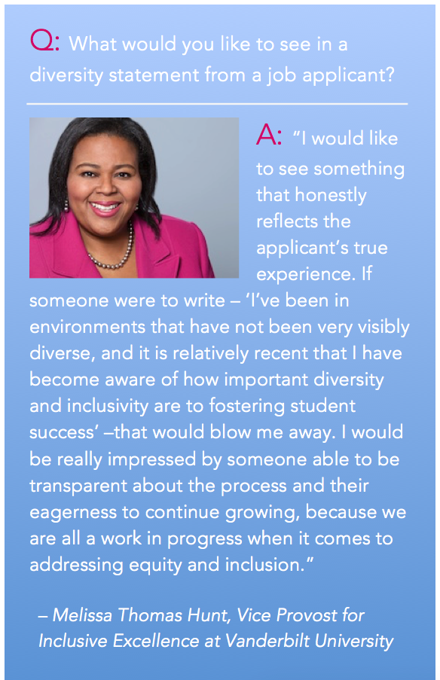Before you get started, clarify for yourself what you mean by “diversity,” or how you intend to use the word in your statement. As you think about diversity, consider related terms like “inclusion” and “equity.” You may or may not define your terms in the statement itself, but you should be very clear on what you mean as you are thinking and writing. You also may wish to reflect on your own frame of reference.
- What are your values regarding diversity, inclusion, and equity in your professional life? Why do you think diversity is valuable in higher education settings? How about in your discipline specifically?
- What kinds of student, staff, or faculty diversity are you thinking of as you answer this question, and are there other ways in which diversity manifests in campus communities that might be valuable to consider?
- What elements of your own identity inform your teaching, research, or scholarship in a tangible way?
It is worth noting that diversity statements are fundamentally about your values, commitments, and capabilities, and not necessarily your identity and the ways it shapes your work. If you choose to disclose your identity in a diversity statement, you should be aware of some issues.

Should You Self-Disclose Elements of Your Personal Identity?
Note that some people wish to share elements of their personal background in their actual statement, and many do not. Reflecting on your own frame of reference can be useful regardless. Some degree of transparency may help readers contextualize the experiences and approaches you detail in your statement. For example, you may wish to share that you grew up in a bilingual household or that you attended graduate school as an international student, if either has influenced your approach to mentorship or teaching. A 2014 study investigated the content of 191 cover letters for faculty positions in which applicants were specifically asked to address diversity and inclusion; less than a quarter of applicants self-disclosed some aspect of their personal identity (Schmaling, Trevino, Lind, Blume, & Baker, 2014). Despite the low percentage of applicants who chose to self-disclose and despite the authors’ note that they could not determine which applications advanced as a function of the applicants’ choice to self-disclose, they write that “self-disclosing one’s diversity may reconceptualize membership in a previously stigmatized group as an advantage, particularly if the self-identification reinforces a coherent academic and professional identity (Schmaling et al., 2014, p. 10)..”
However, be advised that there is risk in disclosing details that may carry stigma or induce subtle biases on the part of readers. For example, some research confirms that biases toward African Americans and women influence evaluation of written application materials (Dovidio & Gaertner, 2000; Moss-Racusin, Dovidio, Brescoll, Graham, & Handelsman, 2012), specifically when the application is not exceptionally weak or exceptionally strong (Dovidio & Gaertner, 2000). The potential benefit of self-disclosing one’s mental health history or sexual orientation, for example, should be carefully weighed against the risk. To be sure, an excellent statement can be written without sharing elements of personal identity, and some universities that request statements are beginning to highlight this. The University of San Diego’s published guidelines to writing a diversity statement, for example, emphasize their desire to identify candidates who share the institution’s commitment to inclusive excellence, “regardless of personal demographic characteristics.”

Writing Prompts
The following prompts are meant to help you identify areas of strength to highlight in your diversity statement. For each of the following areas, think about your past experience and what you plan to do in the future. You don’t need to answer every question, as all may not apply.

Research and Scholarship

Does your research/scholarship directly address issues of diversity, inclusion, or equity? If so, how?
• Does your research/scholarship address issues specific to marginalized groups? If so, describe the connection.
• Has your research/scholarship been shared with the community or public in a way that promotes access to scholarship?
• Has your scholarship involved collaboration with diverse groups of colleagues or commentators?

Mentorship and Advising
- Have you worked with any students in a mentorship or advisory capacity who are from marginalized groups? If so, how did you help them identify and overcome barriers to success? Think about your experience with research mentorship, teaching or tutoring, academic advising, and community mentorship.
- If you plan to train undergraduates and/or graduate students in your future role, what efforts will you make to recruit and retain students from marginalized and underrepresented groups?

Teaching
- How do you plan to serve a student body that is diverse in a multitude of ways? Think not just race, ethnicity, and SES, but about age, religion, academic preparedness, disability, gender expression, or other differences.
- How does your approach to course design take into account considerations of diversity? You may wish to reflect on using a range of assessments, preventing bias in grading, diversifying course content, using inclusive language in the syllabus and classroom, or utilizing student feedback to improve classroom culture or tone. Try to generate at least one specific example of how your decision affects student’s learning in your course. (Note: One prominent example of inclusive syllabus language is diversity statements within syllabi; see examples from Brown University, Yale Center for Teaching and Learning, and The Eberly Center at Carnegie Mellon University)
- What do you do as a teacher that creates a welcoming and inclusive atmosphere? How do you ensure that students in your class feel a sense of belonging?
- How does your approach to facilitating discussion (and/or structuring active learning activities) take into account considerations of positionality, power, and/or diversity? You may wish to reflect on using semi-structured discussion techniques, online access points for student participation, classroom seating arrangements, or other ways in which you create opportunities for student engagement. Try to generate at least one specific example of how your pedagogical choice facilitates student engagement in a particular course.
- Does your discipline lend itself to dialogue about diversity? If so, how do you incorporate this dialogue into your courses? Describe the impact of doing so on student learning and engagement.
- How do you ensure that your course readings and sources reflect diverse perspectives? Have you had any experience diversifying/decolonizing content for your courses, and if so, what has been the impact on student learning.

Adapting your Statement for a Job Application
After you have developed a statement that reflects your strengths and experiences related to diversity, inclusion, and equity, you may wish to tailor it for individual job applications. Be sure to do your homework about diversity-related programs and resources at the schools to which you are applying, and consider including how you plan to contribute to or expand existing programs at that institution. For example, if you have been particularly active in social justice initiatives and are applying to a school with no existing programs addressing race, power and privilege in higher education, it may be appropriate to propose a program modelled on something you’ve already done. However, you do not need to propose a new diversity-related program to write an effective diversity statement. Perhaps you envision your contribution as serving on faculty committees related to diversifying curriculum in your department or advising LGBT-student groups or research initiatives. Be honest about where you are and how you can contribute.

Additional Resources
- Carnegie Mellon University, Global Communication Center. “Writing Your Diversity Statement.”
- Golash-Boza, T. (2016). “The Effective Diversity Statement.” Inside Higher Ed.
- University of California: Contributions to Diversity

References
- Dovidio, J. F., & Gaertner, S. L. (2000). Aversive racism and selection decisions: 1989 and 1999. Psychological Science, 11(4), 315-319. http://dx.doi.org/10.1111/1467-9280.00262
- Schmaling, K. B., Trevino, A. Y., Lind, J. R., Blume, A. W., & Baker, D. L. (2015). Diversity statements: How faculty applicants address diversity. Journal of Diversity in Higher Education, 8(4), 213-224. http://dx.doi.org/10.1037/a0038549
- Moss-Racusin, C., Dovidio, J. F., Brescoll, V. L., Graham, M. J., & Handelsman, J. (2012). Science faculty’s subtle gender biases favor male students. PNAS Proceedings of the National Academy of Sciences of the United States of America, 109(41), 16474-16479. http://dx.doi.org/10.1073/pnas.1211286109
- University of California: Contributions to Diversity

